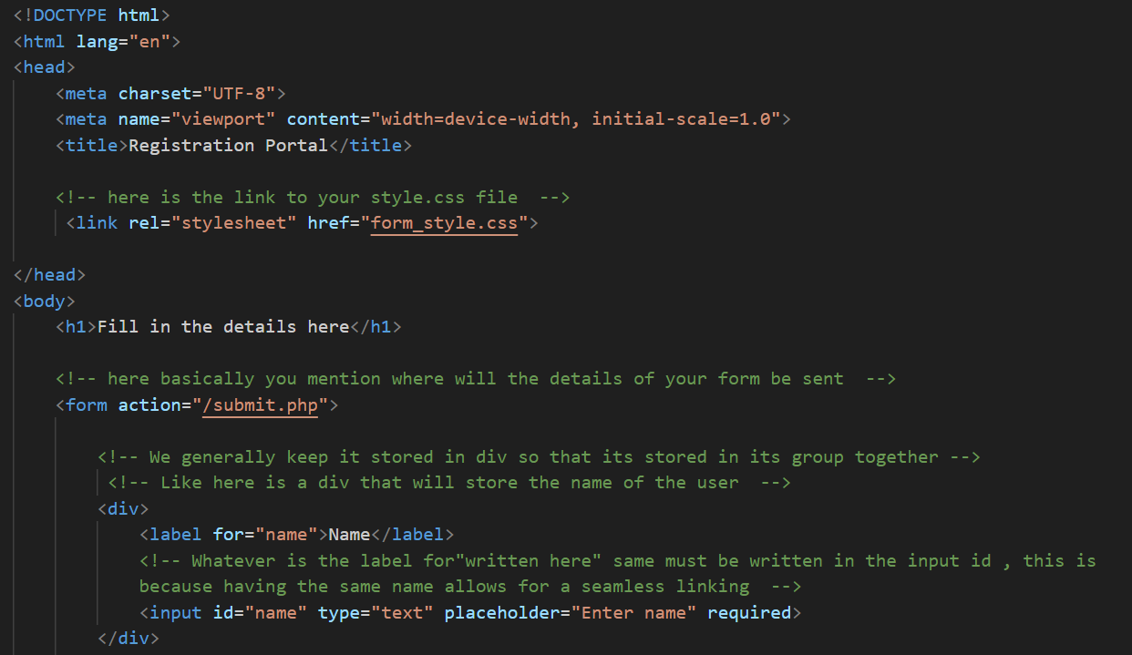
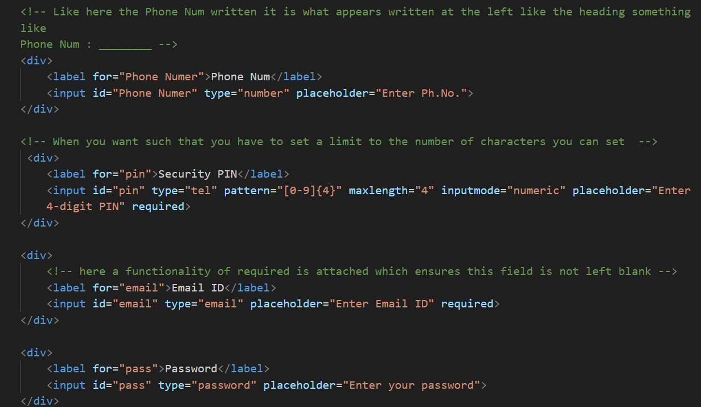

You can also use the concept of text box area , that creates a text box type place where you can have feedback etc type of things.
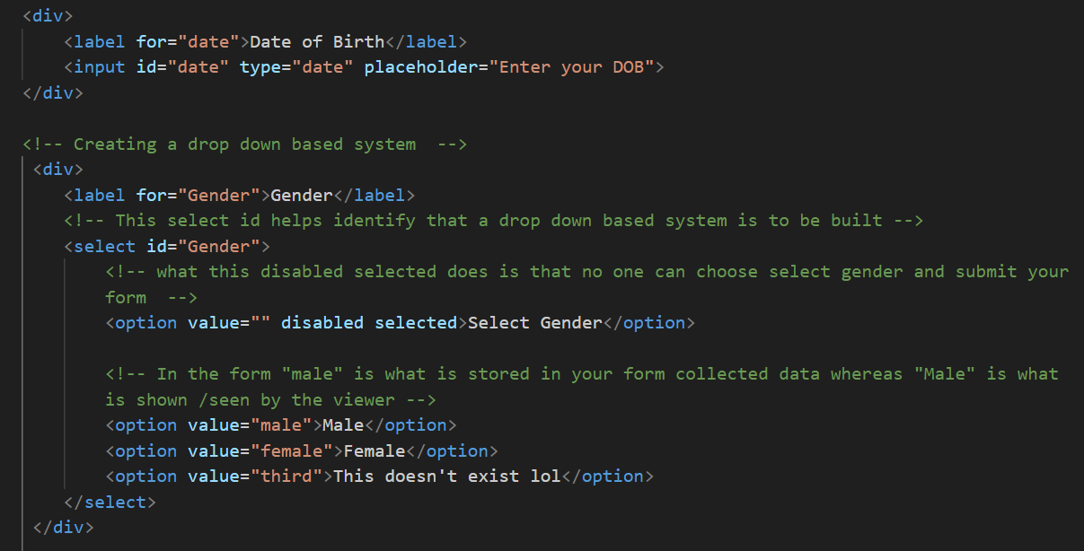
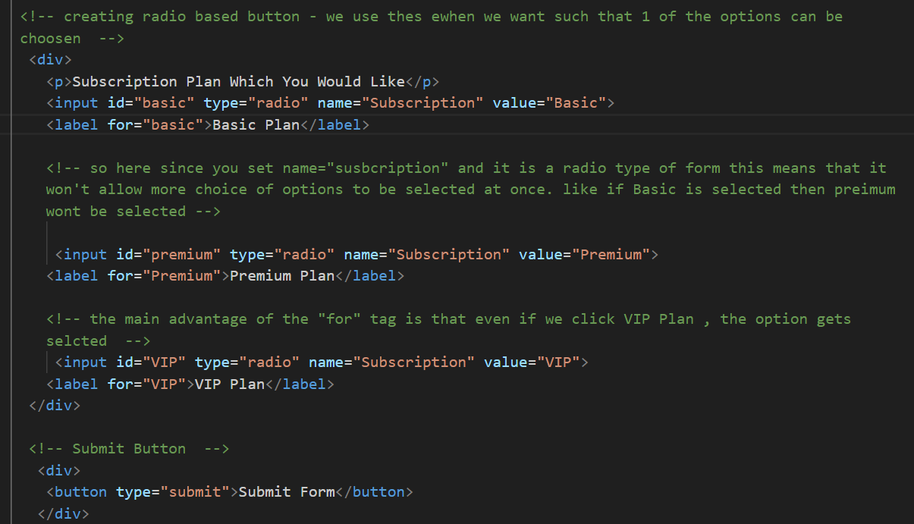

EMBEDDING A VIDEO –
<video src= “ “> Error </video>

Inserting a youtube video – for this just copy and paste the embedded link into the code

